KEILA’S KITCHIN

Zakeila was a most amazing Dalmatian! Abandoned at Station 7 of Southern Manatee Fire Department, Florida in 1992, after surviving on pizza provided by generous firemen, DeLania Lockliear, long-time Paramedic and Co-Founder of Equestrian Spirits, Inc., brought the dog home.

A visit to the vet concurred she had not only delivered puppies a few short weeks earlier but, sadly, she had not been nursing recently. We were never to learn the fate of those puppies, but after a brief adoption which failed miserably when the dog barked incessantly, she was delivered into my hands.

My name is Laurie Wolf. From the moment I laid eyes on Keila, I knew she’d spend the rest of her life with me. Being barely a year old when she was dropped at the fire station, she lived a long, happy & exciting existence. In her more than 17 years of life she made friends with people, horses, cats, other dogs, llamas, goats, sheep, cows, rabbits, pet mice, birds, fowl and wildlife. She survived puppies, numerous relocations, helped train & raise horses & provided a constant source of entertainment. Halloween was a favorite, but any chance to dress up & play with hard-working students brought her great joy.

Besides loving me as much as I love her……. Keila loved food. FOOD. FOOD! Keila could eat ANYTHING including the packages it came in, with NO digestive disorders. This is certainly NOT to say we approved of this, but her time as a starving mother who then had her puppies taken from her made a lifetime mark on her thoughts about food; not nutrition…; food.

The once emaciated Dalmatian settled into a wonderful diet of grain-free dry, canned & raw dog food, holistic veterinarians and natural supplements. Treats were nutritious all natural cookies, bones & crackers. She remained a perfect eater for her 16 years with me. HOWEVER, something in her compelled her to devour just about everything edible in sight! Being part of a large Equestrian Training center meant that no matter what rules were posted or taught, people insisted on feeding the ‘poor thing’ every time she begged (her perfect body weight right up until her final breaths went unnoticed by these misguided folks). Keila never chewed a table leg or mauled a pillow but she did eat grapes, chocolate, entire pizzas; & their packages. A guest came for a picnic & farm tour & disregarded our rule to close the doors of their van. While on a lovely tour of animals & scenery, my spotted wonder ate a loaf of bread, a full bunch of grapes, a box of cookies & a pack of cheese crackers. Besides a pudgy tummy, Keila suffered no ill effects & our guests were given whatever we had on hand to compensate their loss. The next time they came; their van door remained tightly closed.

In naming the various structures on our new farm I reflected on Keila, her cast-iron stomach & the gross negligence that caused it. Keila’s Kitchin is where all our dog, cat, rabbit, hog & fish chows are stored. We have cans, dry & raw feeds with supplements, litters & a variety of active remedies. A veritable food haven!

My dazzling darling; may your spirit guard our stash & dwell among endless foods forever!!

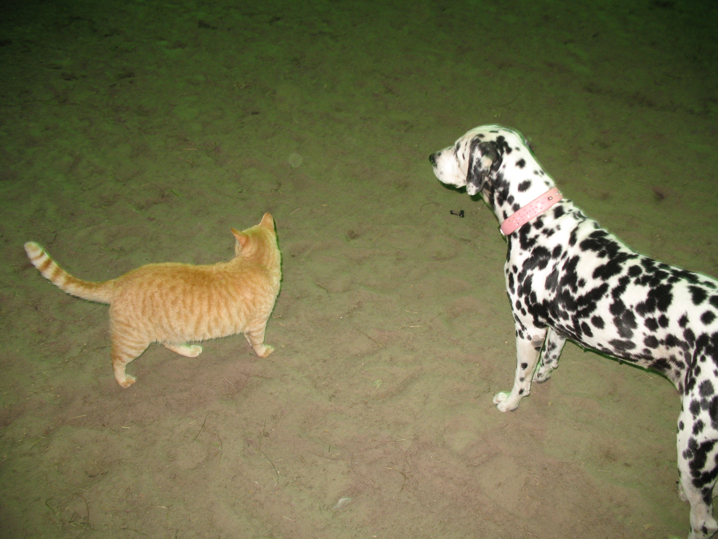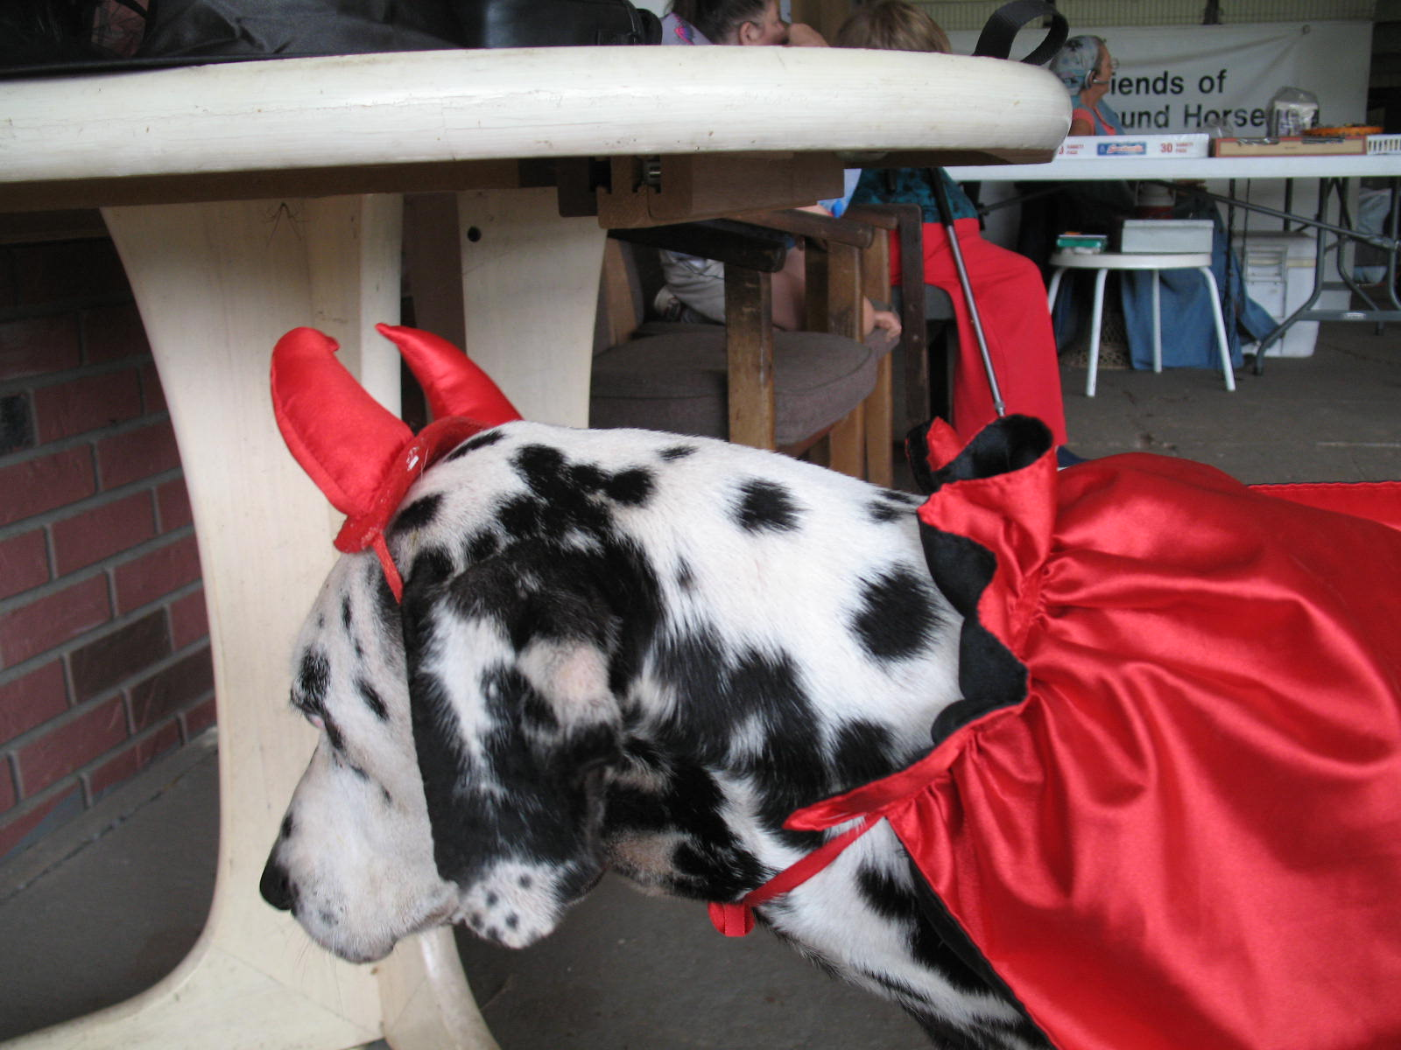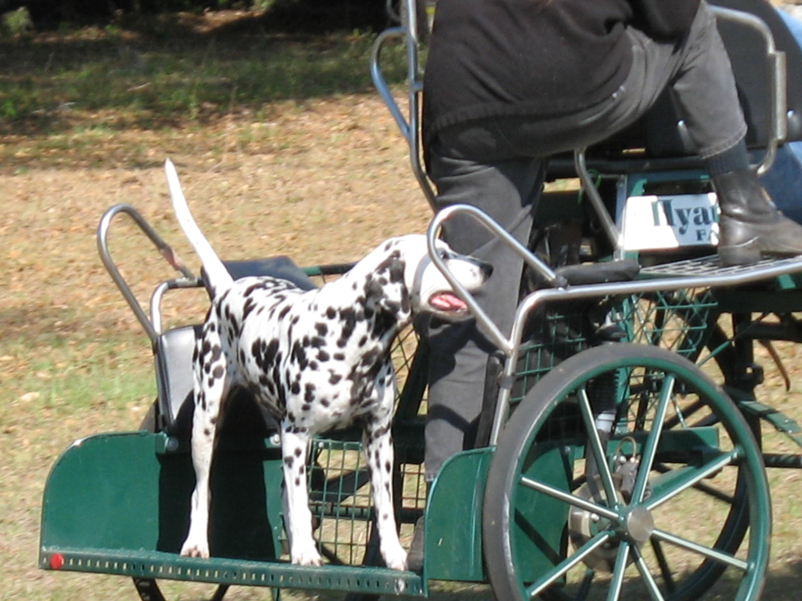
ZAKEILA – the angel of sparks, meteors & comets… - 1991-2009

HOW CAN YOU HELP?

Keila’s Kitchin is kept filled with all the dry & canned foods for dogs & cats, fish food, bunny chows & salad, pig chow, some of the raw meats for dogs & cats, as well as litters, cleaning supplies & active use supplements & remedies.

We have a deep sink, a medium size fridge, electricity, a fan, window, a good floor, good roof & no mice!

What we do need in the Kitchin & surrounding dog facilities:

* Better storage for the needed supplies & the supplies themselves. Shelving, containers & work areas.

* We use a case of cat food every other day & a case of dog food every 3 days. Donations given at Keila’s Kitchin will go towards canned, raw & dry feed goods for the small animals.

* Our dry chows are purchased weekly. Since salads & raw meat do not keep well, they must be replenished more often. Bagged chows take up a lot of room & therefore cannot be stockpiled causing more trips to restock. This takes time, manpower & fuel that could be used for other purposes, so long term we hope to add a store room alongside the Kitchin. This will also allow further discounts due to quantity purchases.

* Donations of towels, litter, newspapers, Dr. Bronner’s, Mrs. Meyer’s & other natural soaps, sponges, cleaning oils…

* Another large trash can for recyclables.

* We plan to paint & decorate the Kitchin; including a sign to identify the structure & a dedication plaque.

* Since the Coyote Dens are adjacent to the Kitchin, we plan to add dog houses, wind breaks, a play field & gardens to ward off the insect populations without the use of harsh chemicals.

* We need to strengthen & extend the boundary fencing for the safety & comfort of our canine residents.

* We hope to paint the building to match other buildings on premises.

* A solar heater to take the edge off the chilly winter nights & heat lamp for outside dogs.

*We are always in need of fly & bug protection for our outside areas. Essential oils, herbs, natural sprays…

* A ‘pool’ large enough for the dogs to play in.

* We hope to set up a garden alongside Keila’s Kitchin & Coyote Den so humans may relax & visit the animals.

Everyone at Equestrian Spirits thanks you for any & all contributions.
Help us keep the critters fed!!!

