THE APOTHECARY
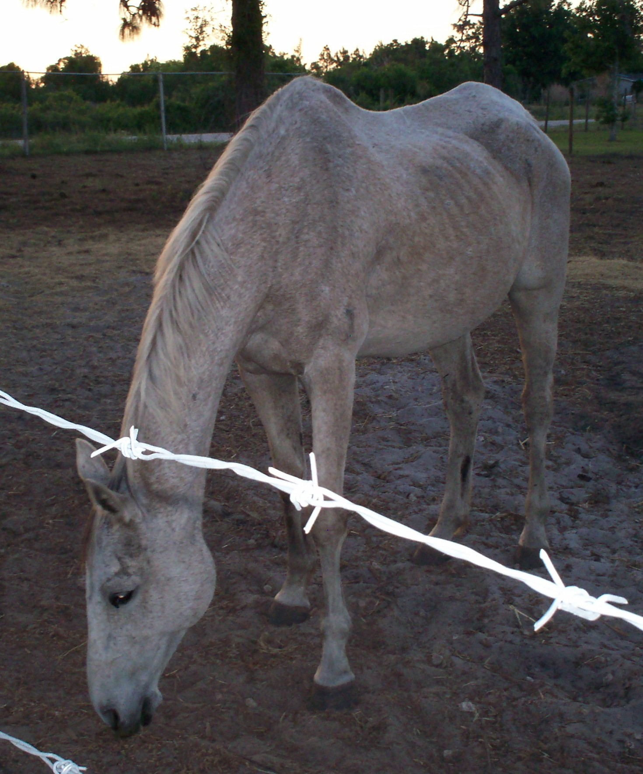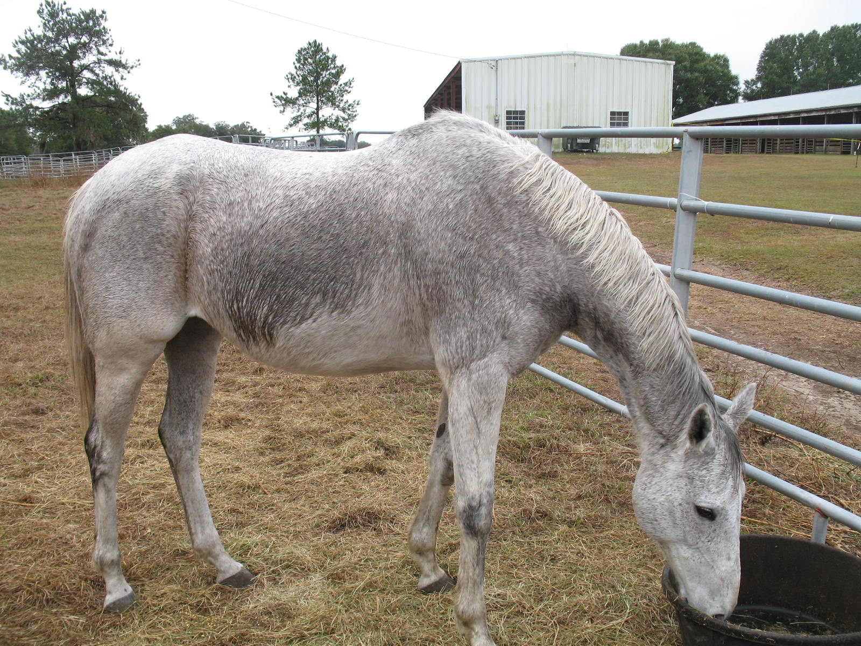
“I will remember that there is art to medicine as well as science, and that warmth, sympathy, and understanding may outweigh the surgeon's knife or the chemist's drug.” from the Hippocratic oath.
At Equestrian Spirits we believe all life is holistic. That is to say, we try to look at everything as a whole. In doing so we may more easily separate the pieces in need of repair & recognize the differences in the things which should remain as they are; at least for a time; even if they may appear to be out of place, damaged, or even some form of threat.
It is with this mind-set we have saved, survived & watched the passage of time.
As a healing nexus for ‘saving spirits’, much of the medicines for our family are in the form of gentle strokes, supportive companionship & kind words. For the times when a physical body is in peril, facing an undisclosed ailment or in need of external intervention, we are blessed to have an array of excellent veterinarians & gifted healers to help us all in the best ways they can.
To support the overall well-being of our residents, we use an extremely wide variety of remedies & products to supplement our emotional foundation. Many of these products are donated by their manufacturer or often times greatly discounted with coupons or an ongoing lowered cost to us. Other products are purchased by benefactors then donated, or remedies they no longer need are sent our way. Since we are a 501(c)(3) all of these types of offerings are tax write-offs in one form or another (please check with your own accountant for any questions pertaining to donations, as each situation may have a different aspect). There are always some items we may need to purchase at full price, so for those we need & appreciate monetary donations.
Some of our items have a very long shelf life, others do not. Many remedies require specific measurements of veterinary support to use correctly. Still others may be prescription or complex in some form. For these reasons we store our ‘medical supplies’ together in our Apothecary. Supplements, remedies, or medicines actively in use for a specific animal or group are usually stationed in areas of easy access. For example; equine supplies may be in the feed room, barn or even stored on a fence-line, whereas small animal’s needs may be stored in their food storage area or at a kennel or pen for safe keeping & rapid access. This also lessens potential confusion about ‘who gets what’…
Along with the remedies themselves, we keep contact information from manufacturers, practitioners, sales representatives, & vets as to their use or any warnings which may be necessary. We also provide a series of check lists ranging from ‘what to do in an emergency’ protocols for colics, injuries or other related situations, to dosage charts, inventories, ‘how to use’ a therapy light or technique such as Bowen to a shopping list to replenish low supply items. Emergency numbers are listed here as well as a variety of locations around the property.
It is in a spirit of healing & the maintenance of the quality of life that we collect, use & share the awe-inspiring information we learn.
For those without faith no proof is possible; for those with faith, no proof is necessary… adapted from Saint Thomas Aquinas 1225-1244

Photo credit: FreeSpiritt - Daughter of Spectacular Bid; saved by ES 2007-2013; passed quietly in her sleep; happy and in full flesh just short of 34yrs old. Co-owner/sponsor Jan Ault, Indiana. As of 2015 Jan also co-owned/sponsored FhanzhiFree, granddaughter of Spectacular Bid.

! HOW YOU CAN HELP !

The Apothecary & adjoining feedroom are in great need of a new roof or at the very least, quality roof repair
Electricity does not work properly
Need fan, outlets & improved lighting
Small fridge for perishables
Repair ceiling
Paint – inside/out
Reestablish supplies from past theft
Repair wall damage – mice
Improve steps
Water supply/sink
Hot water/heater/spigot
Shelving
Work table
Enclosed cabinet for breakables
AC/heat/dehumidifier
Dosing scales – dry & liquid
Mortar/pestle
Update & refill remedies
Storage bins – large for storage – small for individual treatments
Drawer organizers
Cleared area for cart access
Minimal office supplies for charts, etc (notebooks, paper, pens, white boards…)
Portable remedy kits
Plaque for namesake & oath
Natural rodent & bug deterrents – sprays, herbs, plants, essential oils, etc.
Repair main access door

Garden for quiet times to ease the hearts & rest the bones of our human friends & volunteers

